Assignment 1 :

- Draw a labeled diagram of a desktop PC, clearly marking the motherboard, CPU, RAM, GPU, and both HDD and SSD storage components.

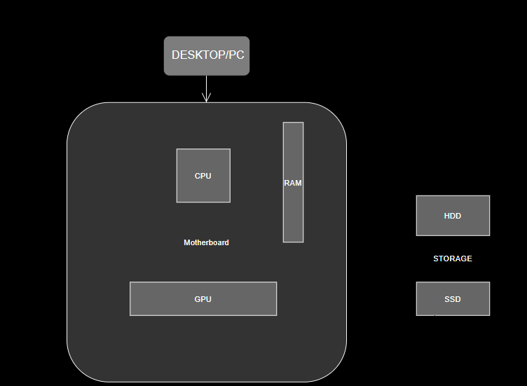

Q2: Create a comparison table showing the main differences between HDD and SSD storage in terms of speed, durability, and typical use cases. Think about which one is faster, which is more shock-resistant, and where you would usually find each type (laptop, gaming PC, etc.)

Feature |  | HDD (Hard Disk Drive) |  | SSD (Solid State Drive)
Speed |  | Slower (typically 80–160 MB/s) |  | Much faster (typically 500 MB/s to 7000+ MB/s depending on SATA/NVMe)
Durability |  | Less durable because it has moving mechanical parts |  | More durable because it has no moving parts and is shock-resistant
Shock Resistance |  | Low – can be damaged by drops or vibrations |  | High – better withstands shocks and vibrations
Storage Capacity |  | Large capacities available at lower cost |  | Usually smaller capacity for the same price, though larger SSDs are available
Price | Cheaper per GB |  | More expensive
Noise |  | Produces some noise while operating |  | Silent operation
Power Consumption |  | Uses more power |  | Uses less power
Typical Use Cases |  | Desktop PCs, file storage, backups, CCTV systems |  | Laptops, gaming PCs, ultrabooks, high-performance desktops, operating system drive

Q3: Write a short explanation (2-3 sentences each) describing the role of the CPU, RAM, and GPU in running a game like PUBG or Free Fire on a PC.

CPU (Central Processing Unit):
The CPU is the main processor of the computer. It handles game logic, player actions, AI, and communication between different hardware components while running games like PUBG or Free Fire.

RAM (Random Access Memory):
RAM temporarily stores the game data that the CPU needs quickly. More RAM helps games load faster and allows smoother gameplay by reducing lag when switching between tasks.

GPU (Graphics Processing Unit):
The GPU is responsible for rendering graphics, textures, lighting, and visual effects. A powerful GPU provides higher frame rates and better image quality, making PUBG or Free Fire look smoother and more realistic.

Q4: Imagine you want to upgrade your PC to run the latest version of FIFA smoothly. List which hardware components you would consider upgrading and explain why for each.

RAM (Memory)
Upgrade the RAM to at least 8 GB or 16 GB. More RAM helps the game run smoothly and reduces lag when loading players, stadiums, and other game data.

Graphics Card (GPU)
A better GPU improves graphics quality, frame rates, and visual effects. This is one of the most important upgrades for smooth FIFA gameplay.

Processor (CPU)
Upgrading the CPU improves game performance by handling game calculations, AI, and background tasks more efficiently.

Storage (SSD)
Replacing an HDD with an SSD reduces game loading times and makes the system more responsive.
Cooling System
Better cooling helps prevent overheating during long gaming sessions and keeps the PC running efficiently.

